Programming Assignment

The importance of flowcharts or pseudo code is that they help us to build a conceptual model of how a program will work before we get into the complexity of the programming language. The conceptual model should define the flow of the program and the actions that the program must take in order to solve the programming problem that we are attempting to solve. If a programmer sits down and simply tries to write code to solve a particular programming problem before considering how to solve the problem and developing a good idea of how the program should be constructed it will be very difficult for the programmer to successfully write the program.

For this assignment you must develop and submit either pseudo code or a flowchart for the following programming problem. Your conceptual model should have sufficient detail that a programmer should be able to develop a program solely from your conceptual model.

**Assignment:**   
Assume that you have just been given an assignment to develop a Python program that will act as a calculator. The calculator must prompt the user to enter two numbers and an operation. The operation can be to add, subtract, multiply, or divide the two numbers. The program must check that the user has not entered the value 0 for either of the two numbers. The program must also check that the user has entered one of the 4 value operations (add, subtract, multiply or divide). The program must perform the appropriate calculation and must display the results. Your assignment is to develop the conceptual model for this calculator. You can develop your conceptual model using either pseudo code or a flowchart. Your conceptual model must be readable as a word document or pdf file and submitted as part of your assignment.

**PSEUDOCODE:**

Prompt user to enter number 1

Check number (num1) does not equal 0

IF num1 = 0

Prompt user again (step 1)

ENDIF

Save input to num1

Prompt user to enter number 2

Check number (num2) does not equal 0

IF num2 = 0

Prompt user again (step 1)

ENDIF

Save input to num2

Prompt user to enter an operation (options: +=1, -=2, *=3, / =4)

Computer operation if input is 1-4, otherwise reprompt

IF operation =1

Compute num1 + num2

WRITE result

ELSEIF operation = 2

Compute num1-num2

WRITE result

ELSEIF operation = 3

Compute num1*num2

WRITE result

ELSEIF operation = 4

Compute num1/num2

WRITE result

ELSE

Reprompt user for operation (1-4)

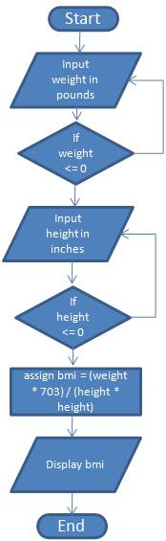Example:   
The following shows an example of a similar assignment that develops a conceptual model for a calculator that computes a person’s body mass index or BMI.

The formula for computing BMI is: (weight in pounds * 703) / height in inches squared

The following will be the items used in the grading rubric of this assignment. Make sure that you have addressed each item in your assignment. You should submit your pseudo code as a word formatted document, or if you create a flowchart, please copy the images and paste them into a word document. If you are using Dia you should export your drawing as a file of type jpeg and then insert the .jpg or .jpeg file into a word document. You should only attach documents in the word format. Both Microsoft Word and OpenOffice can save files in Word 97/2000 format. (the file will have a .doc file extension)